

1. Introduction 2
2. Telenor charges 2
2.1 Format 2
2.2 Adding adjustments to Bans 2
2.2.1 Preparation 2
2.2.2 Uploading 3
2.2.3 Demon 3
2.3 Epilogue 3

Introduction
The purpose of this document is from a funtional view. The intended target is workers within operation. The described process starts with the reception of a electronic document sent from Telenor. The document contains charges to Netcom subscribers using Telenor services. The charges are then added as adjustments to Bans.

Telenor charges

Format
The Format is a flat file with two (2) header records. Table 2.1 outlines an example file.

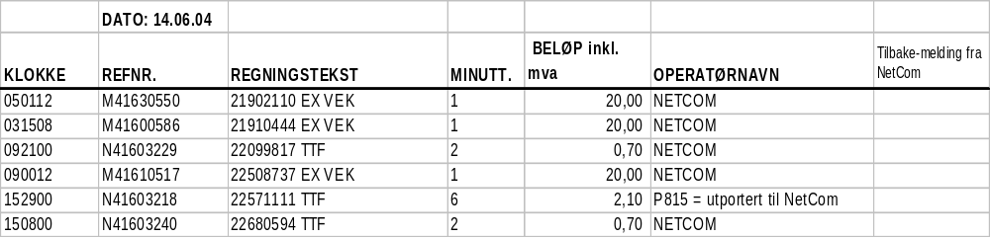table 2.1

Adding adjustments to Bans
A demon, batchTelenorChargeAdditions, handles additions of adjustments to Bans. The demon job takes its input from the Ninja database table, batch_telenor_chgs_processing. It processes automatically all records in ‘WAITING’ status.

Preparation
As per writing, Telnor sends the charging file as an Excel document. To be able to process this file it must be saved as a flat text file accordingly to table 2.1. Do the following:

- Open the document in Excel.
- Save it in CSV(MS-DOS) *.csv format (semicolon separated)
- Open the text file in a text editor.
- Delete the (2) two header records.
- The fifth column <BELØP ikkl. mva> must have period (‘.’) decimal separator. Replace when necessary.
- Save the file as tnor_charges.txt.

Uploading
To upload the prepared Telenor charges data, a SQL Loader script exists that uploads to db table batch_telenor_chgs_processing. Do the following:

- Logon to ernst, using user = ‘ninja’ and password ‘ninja2002’.
- Change directory (cd) into ~/sqlLoaders/batchTelenorCharges.
- Enter ls –l and identify the executable batch_telenor_charges_loader.
- Ftp the Telenor charges, tnor_charges.txt, into current directory. If a file with that name already exists, it must be moved/renamed before transferring or overwritten in the process of transfering.
- Run the SQL Loader, .\ batch_telenor_charges_loader.

All newly uploaded records have ‘WAITING’ status.

Demon
A demon, batchTelenorChargeAdditions, processes all records in ‘WAITING’ status in db table batch_telenor_chgs_processing. The demon runs Tuxedo services against Fokus to add adjustments onto Bans. When a record is processed it changes the status into either ‘PRSD_SUCCESS’ or ‘PRSD_ERROR’ depending on the result. For error, status is equal to ‘PRSD_ERROR’, the reason of failure is available in <STATUS_DESC> column.

The batchTelenorChargeAdditions demon is not running on a regular basis and have to be enabled. Do the following:

- Browse the Ninja db table, ninja_jobs_redesign.
- Identify the entry with ‘batchTelenorChargeAdditions’ in the <EXEC_METHOD> column.
- Update the <JOB_STATUS> column into ‘STARTING’ for the entry identified by 2..

By updating <JOB_STATUS> into ‘STARTING’ a demon scheduler activates the specific demon.

Epilogue
To verfy that all records have been processed by the batchTelenorChargeAdditions demon this SQL may be used:

SELECT * FROM batch_telenor_chgs_processing a WHERE a.status = ‘WAITING’

The query returns no records when all uploaded records are processed.

